**Title**: Login Page – Username and Password Fields Allow Excessive Characters  
**Environment**:

* **Browser**: Chrome Version 131.0. (64-bit)
* **Operating System**: Windows 11
* **Device**: Desktop

**Description**:  
The username and password input fields allow an excessive number of characters to be entered without any limitation, which is unusual for a login form.

**Steps to Reproduce**:

1. Navigate to [**https://www.saucedemo.com/v1/index.html**](https://www.saucedemo.com/v1/index.html) using Chrome on a desktop.
2. Click on the "Username" and "Password" fields.
3. Enter e.g., 100 characters or more.

**Expected Result**:  
The username and password fields should limit the input to a reasonable number of characters (e.g., 32-64).

**Actual Result**:  
The username and password fields accept an excessive number of characters without any restriction, which may lead to security or usability issues.

**Frequency**: Always  
**Severity**: Low  
**Attachments**:   
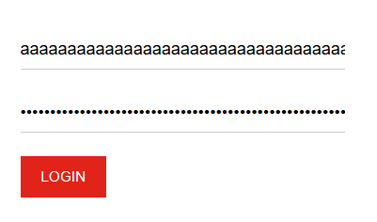

**Title**: Homepage - Sorting Dropdown Does Not Retain Selection  
**Environment**:

* **Browser**: Chrome Version 131.0. (64-bit)
* **Operating System**: Windows 11
* **Device**: Desktop

**Description**:  
The product sorting dropdown resets to the default selection after refreshing the page, even when a different option was selected previously.

**Steps to Reproduce**:

1. Log in to [**https://www.saucedemo.com/v1/index.html**](https://www.saucedemo.com/v1/index.html) as username "standard_user" and password "secret_sauce".
2. Navigate to the homepage.
3. Select a different sorting option (e.g., "Price (low to high)").
4. Refresh the page.

**Expected Result**:  
The sorting dropdown should retain the selected option after a page refresh.

**Actual Result**:  
The dropdown resets to the default sorting option ("Name (A to Z)").

**Frequency**: Always  
**Severity**: Medium

**Title**: Cart Page - Quantity Selector Missing  
**Environment**:

* **Browser**: Chrome Version 131.0. (64-bit)
* **Operating System**: Windows 11
* **Device**: Desktop

**Description**:  
The cart page does not provide an option to update the quantity of items directly, requiring users to remove and re-add items to change the quantity.

**Steps to Reproduce**:

1. Log in to [**https://www.saucedemo.com/v1/index.html**](https://www.saucedemo.com/v1/index.html) as username "standard_user" and password "secret_sauce".
2. Add an item to the cart.
3. Navigate to the cart page.
4. Attempt to change the quantity of the item in the cart.

**Expected Result**:  
A quantity selector (e.g., dropdown or input field) should be available to allow users to adjust the number of items directly on the cart page.

**Actual Result**:  
There is no option to update the quantity of items in the cart; users must remove the item and add it again with the desired quantity.

**Frequency**: Always  
**Severity**: Low  
**Attachments**:   
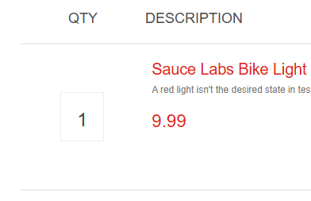

**Title**: Missing Product Images  
**Environment**:

* **Browser**: Chrome Version 131.0. (64-bit)
* **Operating System**: Windows 11
* **Device**: Desktop

**Description**:  
When logged in as "problem_user", the product images are missing from the homepage, leaving empty spaces where images should be displayed.

**Steps to Reproduce**:

1. Log in to [**https://www.saucedemo.com/v1/index.html**](https://www.saucedemo.com/v1/index.html) as username "problem_user" and password "secret_sauce".
2. Navigate to the homepage.
3. Observe that some or all product images are missing.

**Expected Result**:  
Each product should have a visible image associated with it.

**Actual Result**:  
All product images are missing, leaving empty spaces or broken image icons.

**Frequency**: Always  
**Severity**: Medium  
**Attachments**:

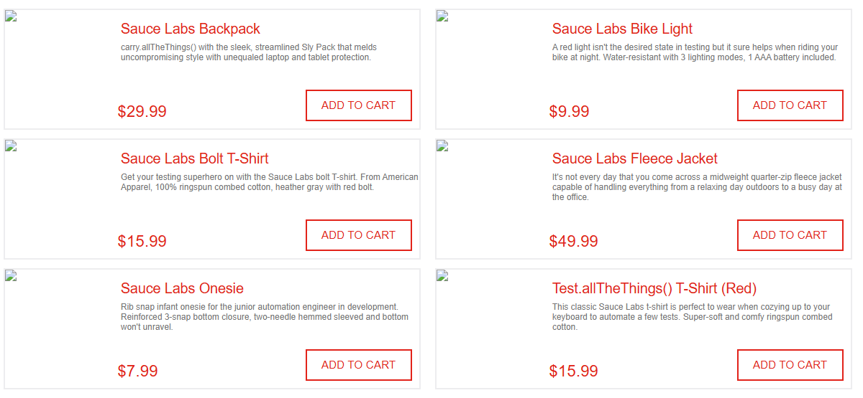

**Title**: Unable to Remove Item from Cart After Adding from Homepage  
**Environment**:

* **Browser**: Chrome Version 131.0. (64-bit)
* **Operating System**: Windows 11
* **Device**: Desktop

**Description**:  
When logged in as "problem_user", after adding an item to the cart from the homepage, the user is unable to remove the item after clicking the "Remove" button. Clicking the "Remove" button does not have any effect.

**Steps to Reproduce**:

1. Log in to [**https://www.saucedemo.com/v1/index.html**](https://www.saucedemo.com/v1/index.html) as username "problem_user" and password "secret_sauce".
2. Navigate to the homepage.
3. Add an item to the cart (e.g., Sauce Labs Backpack)
4. Attempt to click the "Remove" button to remove the item from the cart.

**Expected Result**:  
The item should be removed from the cart immediately after clicking the "Remove" button.

**Actual Result**:  
Clicking the "Remove" button has no effect, and the item remains in the cart.

**Frequency**: Always  
**Severity**: High